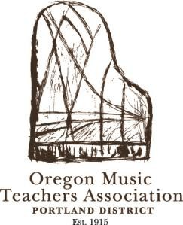
Oregon Music Teachers Association

West Portland District Meeting Minutes

Wednesday, May 25, 2022
In person and streamed on Facebook Live

10:00 a.m. – Program:
“Ebony and Ivory: American Composers from Copland to Ellington”
Dr. Matt Cooper

~~~~~~~~~~~~~~~

CALL TO ORDER
President Elizabeth Caswell called the business meeting of the OMTA West Portland District to order at 11:23a.m. There were approximately 12 members present for the presentation and 12 members present for the meeting, not including Facebook Live viewers. Thank you Dr. Matt Cooper for the wonderful presentation!

APPROVAL OF MINUTES
April 2022 OMTA West Portland Meeting Minutes. Spelling error of Mary Kogen’s name is to be corrected. Minutes stand approved as corrected.

REPORTS
Treasurer Report: Debra Sostrin. The account balance is approximately $30,000.

Membership Report: Celia Bartel. There are currently 195 members in the West Portland District. Members are encouraged to renew their membership early.

ANNOUNCEMENTS
Trula Whelan Festival (Concerto Festival): The Festival will take place at Portland Piano Company on Saturday, June 4th. Students are responsible for bringing their own accompanists.

Festival Dates: 2022/2023 Festival dates will be posted on the West Portland website this week. Mark your calendars!

West-Side OMTA (Hillsboro Area District): Susan Todd. All paperwork has been filed and bank accounts have been established for the new district. The first official Hillsboro District meeting will be June 8th. For members who want dual membership in West Portland and Hillsboro districts, please register for both districts when you complete your MTNA renewal. If you have any issues registering for dual membership, please contact Holly Counts or Susan Todd.

OMTA State Conference: The OMTA State Conference will be held June 23-24 in Florence. In person and virtual registration is still open; visit the OMTA State website for details. We hope to see you there!

President Elizabeth Caswell adjourned the meeting at 11:33a.m.

These minutes were prepared by Secretary Marla Hansen.

~~~~~~~~~~~~~~~

Next Meeting will be September 2022

